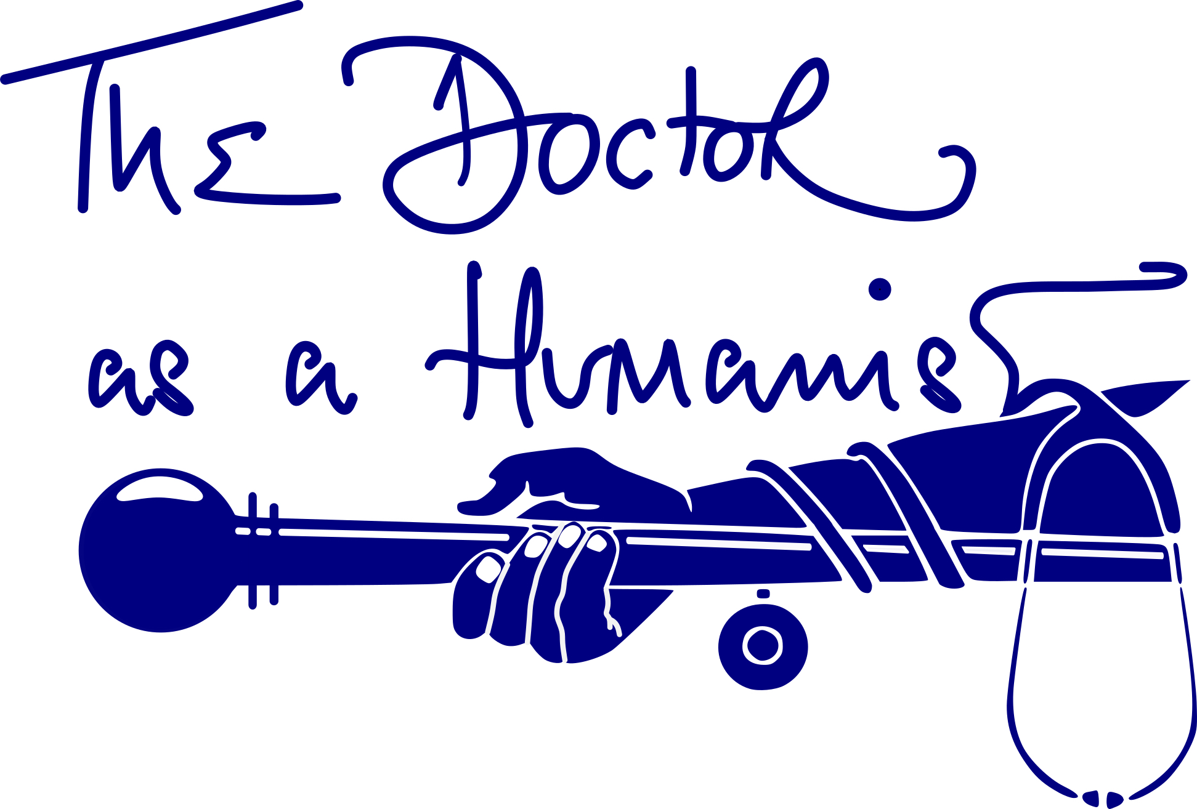
The 5th Online ‘The Doctor as a Humanist’ Course

Date | Subject
17 Dec | Opening and Introduction to Course  Jonathan McFarland (Sechenov University, Moscow and UAM, Spain) Irina Markovina (Prof. Sechenov University, Moscow)  David Cerdio (Anáhuac University, Mexico) Mariam Pogosyan (Sechenov University, Moscow)  Theodora Tselikga (Lecturer – University of Ioannina, Greece) Azar Ghasemi (USERN, Iran)  Roxana Cruce (University of Medicine and Pharmacy of Craiova, Romania)
14 Jan | Medicine through the Ages and Cultures  The Dash Online Team
28 Jan | Mental Health + Humanities  Mirea Ioan-Alexandru (Psychiatrist -Bucharest)  Burcu Alkan (Researcher – University of Manchester, UK)  Eugenia Violeta Nadolu ( Paediatric Psychiatric Nurse, HUSE, Spain)
4 Feb | The Arts and the Sciences  The Limits of Knowledge: Biological and Cultural constraints  Joaquim Gea (Prof. Pompeu Fabra University, Spain) Fernando Giraldez (Prof. Pompeu Fabra University, Spain)

18 FEB | Philosophy and Medicine  A Conversation  Emil Toescu (Prof. University of Birmingham, UK)  Fabrice Jotterand (Professor, Bioethics and Medical Humanities, University of Wisconsin, USA)  Alireza Monajemi (Prof. Institute for Humanities and Cultural Studies, Iran) Maria Elizabeth de los Rios (Prof. Anáhuac University, Mexico)

4 March | Ecologically Dimensioned Medical Humanities  Jonathan Coope (De Montfort University, Leicester, UK)  Jennifer Hartmark-Hill ( University of Arizona, USA)
18 March | Narratives of Medicine  A Conversation  Maria Guilia Marini (Prof. Fondazione Istade, Italy)  Susana Magalhaes (University of Oporto)  Jose Marcos Felix (Anahuac University, Mexico)
1st April | Humanism in Surgery  Jacek Mostwin (Johns Hopkins University, USA)  Manuel Pera (UPF, Spain)  Hector Guadalajra (UAM, Spain)  Pia Maria Sorto ( Helsinki)
15 April | The Arts and Medicine  Ourania Varsou (Glasgow University)  Leonard Shapiro (University of Cape Town)
29 April | Final Presentations and Closing Ceremony  Group Presentations  Jonathan McFarland (Sechenov University, Moscow and UAM, Spain) Irina Markovina ( Prof. Sechenov University)  David Cerdio (Anáhuac University, Mexico) Mariam Pogosyan ( Sechenov University, Moscow)  Theodora Tselikga (Lecturer – University of Ioannina, Greece) Azar Ghasemi (USERN, Iran)  Roxana Cruce (University of Medicine and Pharmacy of Craiova, Romania)

