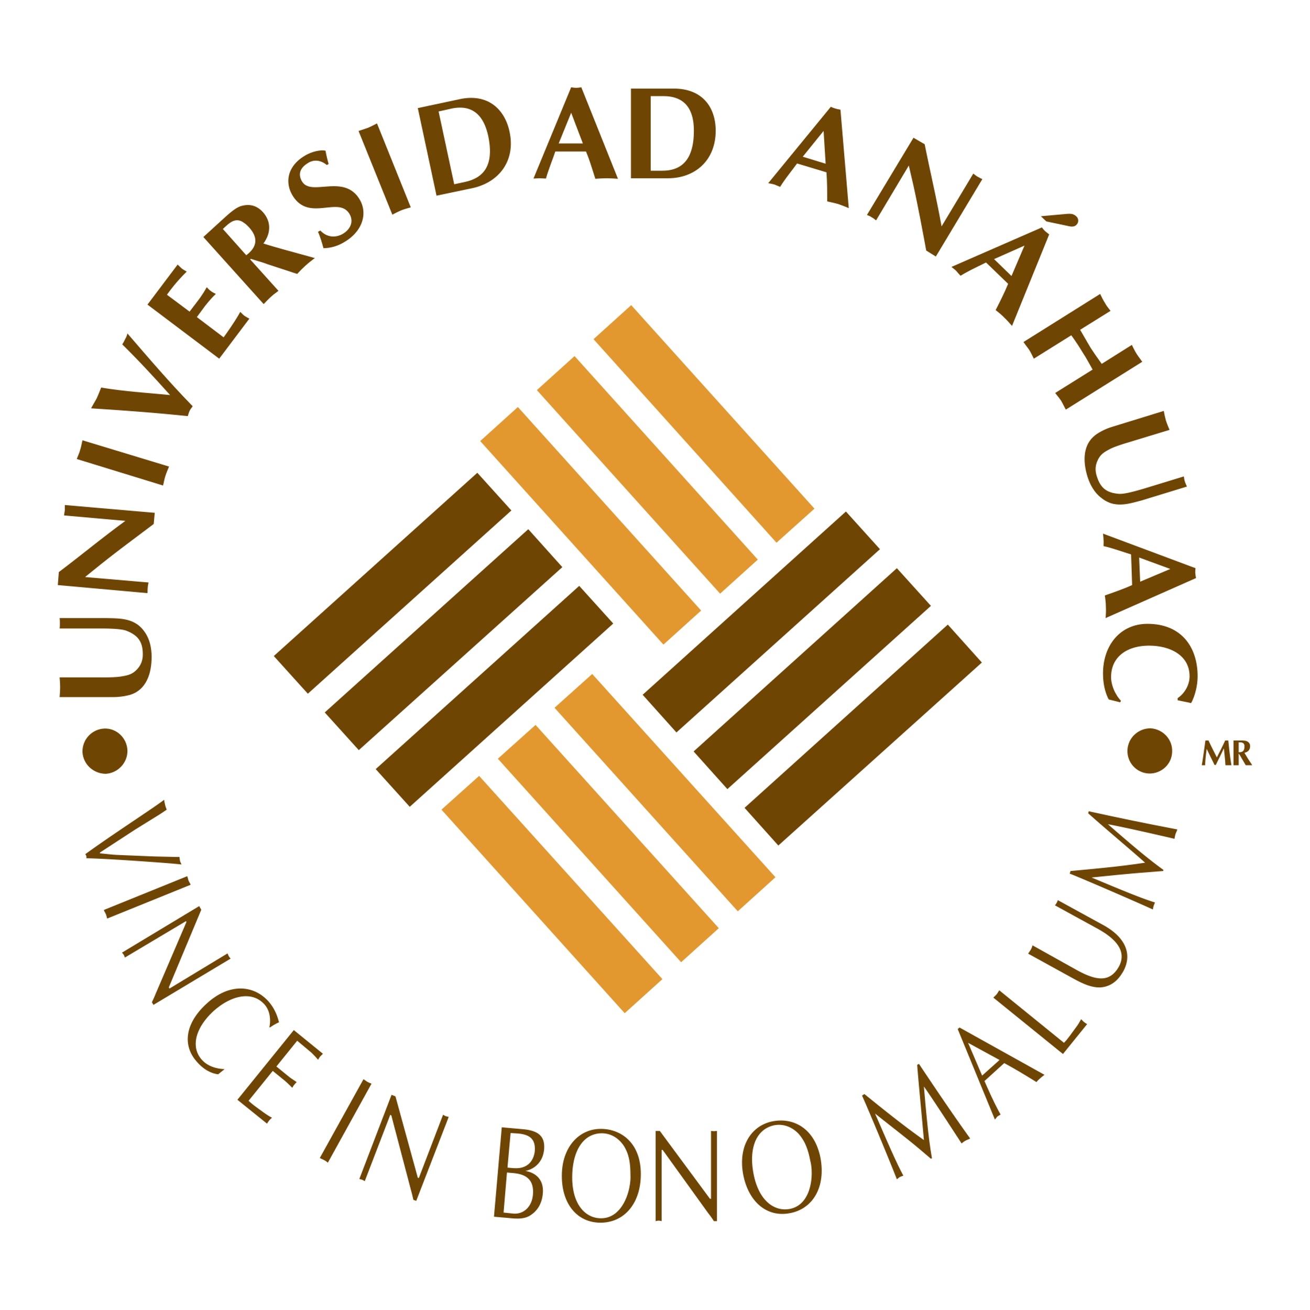
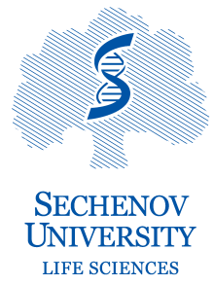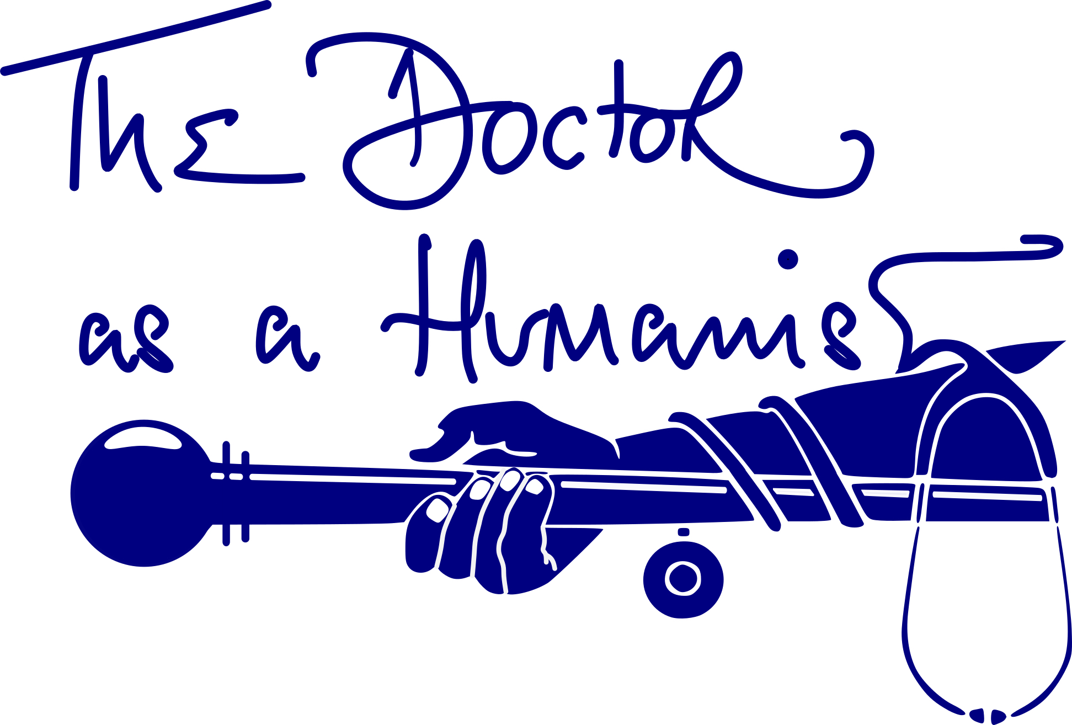
The 5th International “The Doctor as a Humanist” Online Course 2022-2023
What is the International “The Doctor as a Humanist” Online Course?  It is an introductory course on Medical Humanities, whose main aim is to foreground the importance of the Humanities in 21st-century medicine.  Why attend?  We believe that this course is unique and allows healthcare professionals and students from all over the world to listen and debate issues relating to the “humanistic” side of healthcare that will aid them in their daily working lives. It is international, interdisciplinary ,and intergenerational and will offer the participants an opportunity to be part of a vibrant community of reflection; it will - hopefully - inspire future actions and contribute to bringing back the heart and soul to medicine.  The dates  The course will be twice a month on Saturdays and will start on 17th December 2022 until 29th April 2023. Time 14:00-16:00 CET  What topics are covered within the course?  “History and Medicine”, “Narrative Medicine”, “Arts and Medicine”, “Philosophy and Medicine”, “Nature and Medicine”, “Humanism in Surgery”, “Mental Health”, and many more.  Who are the lecturers?  Jonathan McFarland, organiser and leader of the Course, Senior Lecturer, Sechenov University, and Associate Professor (Autonomous Univ. of Madrid).  Prof. Irina Markovina, scientific advisor, Director of the Institute of Linguistics and Intercultural Communication (Sechenov University).  The lectures and seminars are given by internationally experienced professors from among others: Johns Hopkins University, University of Washington (USA), University of Glasgow, De Montfort University (UK), Madrid Autonomous University, UPF (Spain), McGill University, (Canada), and University of Bucharest (Romania).  The final course programme will be announced soon. | Who is the target audience?  All who are interested with a medical background: physicians, nurses, medical students, residents, and post-graduate students.  What will you learn in the Online Course? What skills will you acquire?  Students will understand that medicine is “a science of uncertainty” since it is fundamentally about human interactions and encompasses the humanities, social sciences and the arts.  Among other things, students should learn how to reflect, be critical, and self-critical and understand the importance of empathy, compassion and caring for the patients. We hope students will be able to “think outside the box” and embrace the humanistic values needed more than ever in healthcare.  How to enrol?  The requirements include:  a) Fill in the registration form by 10th December 2022.  https://docs.google.com/forms/d/e/1FAIpQLSfLy8SV2w-_-wJHsQUULOIHs9W-tnabAg3Wt5XkJZeNcQKMlA/viewform  AND  b) pay the fee of 100€. Bank details coming shortly.  Five (5) grants will be awarded to participants based on their motivation letter submitted along with their registration form.  The course is developed for 25 participants.  Contact details:  thedoctorasahumanist@gmail.com  The Team  David Cerdio-Domínguez, Anahuac University  Theodora Tseligka, Univ. of Ioannina  Azar Ghasemi, Kermanshah Univ. of Medical Sciences  Roxana Cruce, University of Medicine and Pharmacy of Craiova  Mariam Pogosyan, FSBI National Med. Research Centre for Obstetrics, Gyn. and Perinatology  https://doctorasahumanist.weebly.com/
Certificates will be awarded upon completion.

